***Experiment 1 :- Design an LED FLASHER***

THEORY :-

Led is used in many places like in our phones, cars, in homes, etc. Mostly electronics lights up due to LED. LED has lots of variety like different sizes, shapes and colors also. They have one common thing : they’re bacon of electronics. LED are a particular type of diode that convert electrical energy into light. LED stands for Light Emitting Diode. It requires less power to glow.

Types of LEDs :- RGB (Red-Green-Blue) LEDs, IR LEDs, SMD LEDs LEDs is used in remotes also for. LEDs guide us to help to avoid any accidental LED barbecues. They are like tiny lightbulbs.

1) Polarity Matters Polarity indicates whether a circuit component is symmetric or not.

2) More Current Equals More Light The brightness of LED is directly dependent on how much current it draws.

3) There is Such a Thing as Too Much Power If we connect an LED directly to a current source it will try to dissipate as much power as it is allowed to draw.

PROGRAM :-

int led_flash=12; connecting LED

void setup() { pinMode(led_flash, OUTPUT); }

Void loop() { digitalWrite(led_flash, HIGH); delay(800);

digitalWrite(led_flash, LOW); delay(800); }

Diagram :-

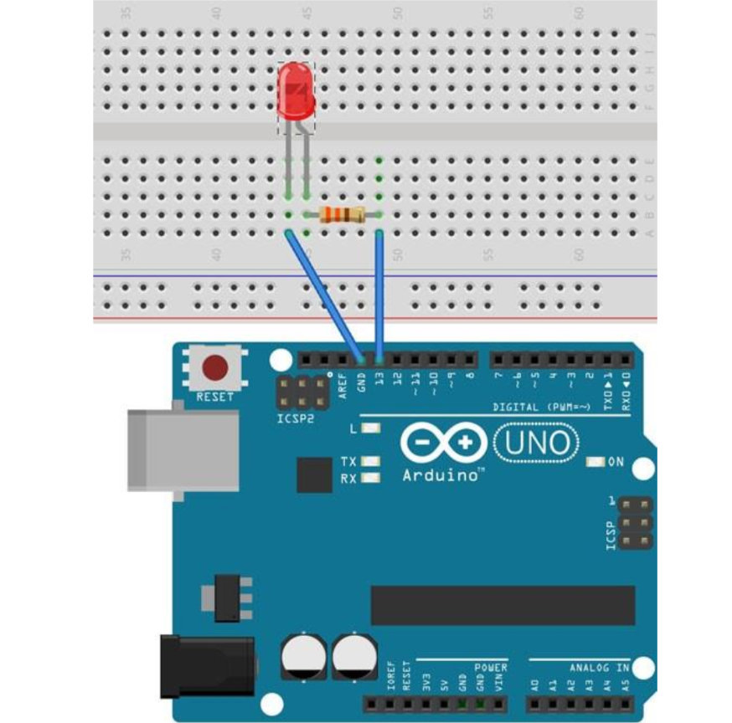

Precautions :- Don’t connect LED directly with high power voltage source.